Part A

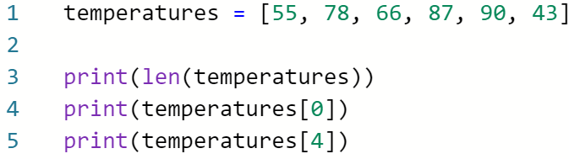



Part B

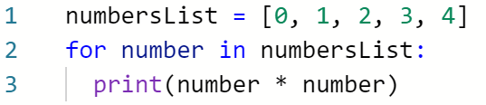



Part C

Your Code Below:

A1. Circle the value at index 3 in the list ***temperatures***.

A2. What is the length of the list ***temperatures***?

A3. Write the output of lines 3, 4, and 5:

Output:

| Line 3: |  |
| --- | --- |
| Line 4: |  |
| Line 5: |  |

A4. What does the function **len()** do in line 3?

B1. In your own words, what does the code to the left do?

B2. What is the output of the code to the left?

C1. Write a list named  ***foo***  that contains 4 String elements "a", "b", "c", "d"

C2. Write a for-each loop that iterates through your list ***foo*** that you created. Have the for-each loop print out each element in the list ***foo***.

C3. Write a function named ***fizzle*** that takes a list as input, does not return any value, but prints out each item in the list it takes in. (Hint: you can re-use the for-each loop you created above to help you write this function.) Fill the plan out below!

